

**Dr. D.Y. Patil School of MCA**

***Charoli (BK), PUNE-******412105***

**SAVITRIBAI PHULE PUNE UNIVERSITY**

# MASTER OF COMPUTER APPLICATION

**Project Report on**

**“DDOS Attack Detection“**

**Under The Guidance Of**

**“Prof. Sapna Chavan“**

**BY**

# “Name : Sachin Lohar Seat No. : 267“

**Class : MCA-II ( Sem-IV)**

**Year : 2023-2024**

Date:-

**CERTIFICATE**

**This is to certify that Mr. / Ms. Sachin Bharat Lohar, has successfully / partially completed his/her project work entitled “DDOS Attack Detection System” in partial fulfillment of MCA -II SEM-IV Mini Project for the year 2023-2024. He / She have worked under our guidance and direction.**

**Place : Pune**

**Date :**

**Prof.** **Sapna Chavan Prof. Santosh Deshmukh Dr. E. B. Khedkar**

**(Project Guide) HOD DYPSOMCA (Director,DYPSOMCA)**

**Index**

|  |  |  |
| --- | --- | --- |
| **Chapter No.** | **Particulars** | **Page**  **Number** |
| **1** | **INTRODUCTION** |  |
| 1.1 | Company Profile | 3 |
| 1.2 | Abstract | 5 |
| 1.3 | Existing System and Need for System | 6 |
| 1.4 | Scope of System | 7 |
| 1.5 | Operating Environment - Hardware and Software | 8 |
| 1.6 | Brief Description of Technology Used | 9 |
| **2** | **PROPOSED SYSTEM** |  |
| 2.1 | Study of Similar Systems (If required research paper can be included) | 10 |
| 2.2 | Feasibility Study | 11 |
| 2.3 | Objectives of Proposed System | 12 |
| 2.4 | Users of System | 12 |
| **3** | **ANALYSIS AND DESIGN** |  |
| 3.1 | System Requirements (Functional and Non-Functional requirements) | 13 |
| 3.2 | Use Case Diagrams | 14 |
| 3.3 | Sequence Diagram | 15 |
| 3.4 | Activity Diagram | 16 |
| 3.5 | Deployment Diagram | 17 |
| 3.6 | Module Hierarchy Diagram | 18 |
| 3.7 | Sample Input and Output Screens | 19 |
| **4** | **CODING** |  |
| 4.1 | Algorithms | 26 |
| 4.2 | Code snippets | 27 |
| **5** | **TESTING** |  |
| 5.1 | Test Strategy | 30 |
| 5.2 | Unit Test Plan | 31 |
| 5.3 | Acceptance Test Plan | 32 |
| 5.4 | Test Case / Test Script | 33 |
| **6** | **LIMITATIONS OF PROPOSED SYSTEM** | 34 |
| **7** | **PROPOSED ENHANCEMENTS** | 34 |
| **8** | **CONCLUSION** | 35 |
| **9** | **BIBILOGRAPHY** | 35 |
| **10** | **PUBLICATION/COMPLETION CERTIFICATES** | 36 |
| **11** | **USER MANUAL** | 37 |

**1. INTRODUCTION**

**1.1. Company Profile**

**Datex Technologies Pvt.Ltd** formerly known as pkSoft Lab India founded in June 2015. We provide best software solution to achieve your critical issues and fulfil the requirements. We deliver high quality business application solutions, which is Scalable, Robust and Easy to maintain. We have multiple Domain expertise and rigorous delivery methodologies.

**We Create**

Software is important to use the computers power or working efficiency to perform those tasks which can not be done or controlled by human, such as, to measuring the temperature of world, distance of planets etc.

**We Look to The Future**

Software developers know this seller’s market won’t last forever. As more people learn to code and tooling becomes more user-friendly, the barrier to entry will lower and the industry will evolve and impact the value of code. Like anything that is abundant, it simply won’t be worth as much.

**Mission**

To lead in the various avenues of Software market, implement novel ideas in project development and deliver cost effective and required solutions to its prospective clients.

* Partnering with various clients help in bringing fresh ideas into the firm ensuring our youth in innovation, thus improving our quality standards accompanied with growth in the business productivity.
* Being a trustworthy and fair business partner.
* Maintaining and upgrading the quality of work and motivating people to constantly deliver work to client's satisfaction.

**Vission**

To earn global admiration as an IT firm, by building and maintaining long lasting relationship with people and technology and deliver functional software and excellent services.

* We ensure an excellent relationship with our internal and external team; our employees and our clients.
* At Datex, team building and close interaction transcends our potential to assist and improve our business productivity and growth.
* We take Customer and client satisfaction as an opportunity to express leadership and deliver valuable services.
* Through expression of transparency and commitment towards our work team and work, we have successfully been able to create an excellent environment within and across the company..

**Letter of Appointment (LOI)**

**1.2. Abstract**

In today's interconnected world, cybersecurity threats like Distributed Denial of Service (DDoS) attacks pose significant risks to organizations and individuals alike. To mitigate these risks, effective intrusion detection systems (IDS) are crucial. This project aims to develop an IDS specifically tailored for detecting DDoS attacks using the KDD99 dataset, a widely used benchmark dataset for intrusion detection research.

The system is implemented in Python and utilizes two machine learning models: Support Vector Machine (SVM) and Random Forest (RF). These models are trained on features extracted from network traffic data to classify whether incoming traffic represents normal behavior or a potential DDoS attack.

The DDOS Attack Detection System is a Python-based solution designed to identify and mitigate Distributed Denial of Service (DDOS) attacks on networks. Leveraging machine learning algorithms like Support Vector Machine (SVM) and Random Forest (RF), the system analyses network traffic data to distinguish between normal and malicious activities. Users can train the system using labelled datasets, and it employs trained models to detect potential DDOS attacks in real-time. The system offers a user-friendly interface for training models, testing against new data, and displaying detection outcomes. With its capability to differentiate DDOS attacks from regular network traffic, it enhances network security and aids in timely response to potential threats. This SRS document outlines the functional and non-functional requirements, system architecture, and user interactions for the DDOS Attack Detection System.

**The project consists of several modules:**

* **Data Preprocessing:** The KDD99 dataset is preprocessed to clean and transform the data into a suitable format for machine learning algorithms. Features such as duration, protocol type, service, and flags are extracted from network packets.
* **Model Training:** Two models, SVM and RF, are trained on the preprocessed dataset. SVM uses a linear kernel, while RF utilizes an ensemble of decision trees. These models learn to classify network traffic as either normal or indicative of a DDoS attack.
* **Model Evaluation:** The trained models are evaluated using performance metrics such as accuracy, precision, recall, and F1-score. The goal is to assess how effectively the models can detect DDoS attacks while minimizing false positives and false negatives.
* **User Interface:** A user-friendly interface is developed to facilitate interactions with the system. Users can train the models, test them on new data, and visualize the results.
* **System Integration:** The IDS is integrated into existing network infrastructure to monitor incoming traffic in real-time. Alerts are generated when suspicious activity is detected, allowing administrators to take appropriate action to mitigate potential threats.

The DDOS Attack Detection System is a Python-based solution designed to identify and mitigate Distributed Denial of Service (DDOS) attacks on networks. Leveraging machine learning algorithms like Support Vector Machine (SVM) and Random Forest (RF), the system analyses network traffic data to distinguish between normal and malicious activities. Users can train the system using labelled datasets, and it employs trained models to detect potential DDOS attacks in real-time.

**1.3. Existing System and Need for System**

**Existing System:**

Traditional intrusion detection systems (IDS) often rely on rule-based or signature-based methods to identify known patterns of malicious activity. While effective to some extent, these systems have limitations when it comes to detecting novel or previously unseen attacks, such as Distributed Denial of Service (DDoS) attacks. Rule-based systems are static and cannot adapt to evolving threats, while signature-based systems require frequent updates to detect new attack patterns. Additionally, both approaches may suffer from high false positive rates, leading to alert fatigue and decreased efficiency for security personnel.

Furthermore, these systems may struggle to handle the scale and complexity of modern network environments, where large volumes of data are generated in real-time. Traditional IDS may lack the scalability and processing power needed to analyze this data effectively, resulting in delayed or missed detections of DDoS attacks. Moreover, the increasing sophistication of cyber threats necessitates more advanced detection techniques beyond simple rule or signature matching.

**Need for System:**

The need for an advanced DDoS attack detection system arises from the growing threat landscape and the limitations of existing intrusion detection methods. DDoS attacks continue to pose significant risks to organizations, disrupting services, causing financial losses, and damaging reputations. As such, there is a critical need for proactive measures to detect and mitigate these attacks in real-time.

**A robust DDoS detection system is essential for several reasons:**

* **Timely Detection:** DDoS attacks can cause immediate and severe damage to networks and systems. A detection system that can identify and respond to these attacks in real-time is crucial for minimizing the impact on operations and ensuring business continuity.
* **Adaptability:** Unlike traditional IDS, which rely on static rules or signatures, an advanced detection system should be adaptive and capable of learning from new data. Machine learning algorithms, such as Support Vector Machine (SVM) and Random Forest (RF), offer the flexibility to detect emerging threats and adapt to changing attack patterns.
* **Reduced False Positives:** By leveraging machine learning techniques, the system can analyze network traffic patterns in depth, leading to more accurate detections and fewer false positives. This helps security teams focus their attention on genuine threats rather than chasing false alarms.
* **Scalability:** With the exponential growth of network traffic and the proliferation of connected devices, a scalable detection system is essential for handling large volumes of data efficiently. By leveraging modern technologies and parallel processing techniques, the system can scale to meet the demands of complex network environments.
* **Maintaining Service Availability:** By promptly identifying and mitigating DDoS attacks, the system ensures that network services remain available to legitimate users, minimizing downtime and disruption to operations.

**1.4. Scope of System**

The DDoS attack detection system presents a comprehensive solution for identifying and mitigating Distributed Denial of Service (DDoS) attacks in network environments. The scope of the system encompasses several key aspects:

* **Detection Capabilities:** The system aims to detect various types of DDoS attacks, including volumetric, protocol, and application layer attacks. By analyzing network traffic patterns and anomalies, the system can identify deviations from normal behavior indicative of a DDoS attack.
* **Machine Learning Models:** The system employs machine learning algorithms, such as Support Vector Machine (SVM) and Random Forest (RF), for DDoS attack detection. These models are trained on labeled datasets to classify incoming traffic as either normal or malicious, based on features extracted from network packets.
* **Real-Time Monitoring:** The system provides real-time monitoring of network traffic to detect DDoS attacks as they occur. Alerts are generated when suspicious activity is identified, allowing administrators to take immediate action to mitigate the impact of the attack.
* **Scalability:** The system is designed to scale horizontally to handle large volumes of network traffic efficiently. By leveraging parallel processing techniques and distributed computing architectures, the system can accommodate the demands of high-traffic environments without sacrificing performance.
* **Customization and Configuration:** The system offers flexibility for customization and configuration to suit the specific requirements of different network environments. Administrators can define thresholds, rules, and policies for DDoS detection and response, tailoring the system to their organization's security needs.
* **Integration with Existing Infrastructure:** The system can be seamlessly integrated into existing network infrastructure and security ecosystems. Integration with firewalls, intrusion prevention systems (IPS), and Security Information and Event Management (SIEM) platforms enables coordinated threat response and streamlined incident management.
* **Reporting and Analytics:** The system provides comprehensive reporting and analytics capabilities to track DDoS attack trends, analyze security incidents, and generate actionable insights for decision-making. Administrators can access detailed reports on detected attacks, response times, and effectiveness of mitigation strategies.
* **User Interface:** The system features a user-friendly interface that facilitates ease of use and accessibility for security personnel. Intuitive dashboards, visualizations, and interactive tools enable administrators to monitor network activity, investigate incidents, and manage security policies effectively.
* **Scalability and Adaptability:** The system is designed to be scalable and adaptable to different network environments and evolving cyber threats. It can accommodate changes in network infrastructure, increasing traffic volumes, and emerging attack techniques through regular updates and enhancements.

Overall, the scope of the DDoS attack detection system encompasses a wide range of functionalities aimed at proactively identifying and mitigating DDoS attacks to safeguard network infrastructure, ensure business continuity, and protect against potential security threats.

**1.5. Operating Environment – Hardware and Software**

**Hardware Requirements:**

1. **Server Infrastructure:** The DDoS attack detection system can be deployed on a dedicated server or a cloud-based infrastructure to handle the processing and storage requirements of large-scale network traffic analysis.
2. **Processing Power:** The server hardware should have sufficient CPU processing power and memory to perform real-time analysis of network packets and execute machine learning algorithms efficiently.
3. **Storage:** Sufficient storage space is required to store system logs, configuration files, and any generated reports or alerts.

**Software Requirements:**

1. **Operating System:** The system is compatible with various operating systems, including:

* Linux: Ubuntu, CentOS, Red Hat Enterprise Linux (RHEL)
* Windows Server

1. **Python Environment:** The system is developed using Python programming language and requires the following software components:

* Python interpreter (version 3.x)
* Python libraries and packages for data preprocessing, machine learning (e.g., scikit-learn, pandas, numpy), and GUI Development (e.g., Tkinter)

1. **Database Management System:** A relational database management system (RDBMS) is used for storing configuration data, user information, and system logs. Commonly used databases include:

* SQLite

1. **Networking Tools:** The system may utilize networking tools and protocols for packet capture, traffic analysis, and communication with network devices:

* Wireshark: for packet capture and analysis

1. **Development Tools:** Software development tools are used for coding, debugging, and version control:

* Integrated Development Environment (IDE) : Visual Studio Code

**Networking Equipment:**

1. **Router/Switch:** The system may require access to router or switch configurations to monitor network traffic and implement mitigation strategies.
2. **Firewall:** Ensure that firewall rules are configured to allow traffic to and from the DDoS Attack Detection System, particularly if it is deployed in a network segment with restricted access.

**Additional Considerations:**

* **Internet Connectivity:** A stable internet connection is necessary for receiving threat intelligence updates, accessing online resources, and communicating with external threat intelligence platforms.
  1. **Brief Description of Technology Used**
     1. **Operating Systems Used:**

The DDoS Attack Detection System is designed to be platform-independent, compatible with a variety of operating systems including Windows, Linux, and Unix-based distributions. This flexibility allows the system to be deployed in diverse environments, catering to the preferences and infrastructure of different organizations. Whether running on a Windows server, a Linux-based appliance, or a Unix workstation, the system maintains consistent functionality and performance across various operating systems.

* **Windows:** The system can run seamlessly on Windows operating systems such as Windows 7, Windows 8, and Windows 10. Windows provides a user-friendly environment for running GUI applications and offers support for various development tools and libraries used in Python programming.
* **Unix-based Systems:** The system is also compatible with Unix-based operating systems such as Linux and macOS. Unix-based systems are widely used in server environments and offer robust performance, security, and scalability. Additionally, Unix-based systems provide native support for Python and Tkinter, making them ideal for running GUI applications developed using these technologies.

Python, Tkinter, and SQLite are cross-platform technologies, meaning that applications developed with them can be executed on various operating systems without significant modifications. Therefore, the application can run seamlessly on Windows, Unix-based systems (such as Linux and macOS), and other platforms supported by Python.

**1.6.2 Database:**

For data storage and management, the DDoS Attack Detection System utilizes a robust relational database management system (RDBMS). Commonly employed RDBMS options include SQLite, MySQL, and PostgreSQL, offering scalability, reliability, and efficiency in handling large volumes of network traffic data. The chosen database system ensures data integrity, enables efficient querying and analysis, and facilitates seamless integration with other components of the system architecture. By leveraging the capabilities of an RDBMS, the system can store configuration settings, network traffic logs, and analytical insights to support effective DDoS attack detection and mitigation strategies.

* **SQLite:** A lightweight, serverless database engine that is well-suited for embedded applications and small-scale deployments. SQLite offers simplicity, portability, and ease of integration with Python applications, making it a suitable choice for storing application data locally.
* **RDBMS:** The database management system used in the code is SQLite, which is a lightweight, file-based relational database engine. SQLite is integrated with Python and does not require a separate server process, making it suitable for small to medium-sized applications.

Overall, the choice of database depends on factors such as the scale of deployment, performance requirements, and data storage needs of the DDoS attack detection system. The system is designed to be flexible and adaptable, allowing users to configure and integrate with a wide range of database solutions based on their specific requirements.

**2. Proposed System**

**2.1. Study of Similar Systems**

The research paper titled "A Novel Framework for DDoS Detection and Mitigation Using Machine Learning Techniques" published in the IEEE Xplore digital library provides valuable insights into a similar system for DDoS detection and mitigation. Here's a brief overview and analysis based on the paper:

**Overview:**

The paper presents a novel framework for detecting and mitigating Distributed Denial of Service (DDoS) attacks using machine learning techniques. DDoS attacks pose significant threats to network infrastructure by overwhelming target systems with malicious traffic, disrupting services, and causing downtime. Traditional detection methods often struggle to accurately identify and mitigate these attacks in real-time, highlighting the need for more advanced and adaptive approaches.

**Key Components:**

1. **Feature Extraction:** The framework extracts relevant features from network traffic data to characterize normal and malicious behavior. Features may include packet header information, traffic volume, protocol types, and temporal patterns.
2. **Machine Learning Models:** Various machine learning algorithms are employed to classify network traffic as either benign or malicious. These models are trained on labeled datasets to learn patterns indicative of DDoS attacks and adapt to evolving threats.
3. **Real-time Monitoring:** The framework provides real-time monitoring of network traffic to detect anomalies and suspicious activity indicative of DDoS attacks. Alerts are generated when deviations from normal behavior are detected, enabling timely response and mitigation.

**Key Findings:**

1. **Effectiveness:** The framework demonstrates promising results in terms of detection accuracy and mitigation effectiveness. By leveraging machine learning techniques, the system can adapt to new attack patterns and improve over time.
2. **Scalability:** The framework is designed to scale with the size and complexity of network environments, making it suitable for deployment in enterprise-level networks and service providers.

**Conclusion:**

The research paper provides valuable insights into a novel framework for DDoS detection and mitigation using machine learning techniques. By leveraging the capabilities of machine learning, the framework offers improved accuracy, scalability, and adaptability compared to traditional detection methods. Further research and experimentation are warranted to evaluate the framework's performance in real-world scenarios and assess its effectiveness in mitigating advanced DDoS attacks.

**2.2. Feasibility Study**

A feasibility study is essential to assess the viability and practicality of implementing the DDoS attack detection system. It evaluates various aspects such as technical feasibility, economic feasibility, and operational feasibility to determine whether the project is feasible and worth pursuing. Here's an analysis of each aspect:

**Technical Feasibility:**

* **Resource Availability:** Evaluate whether the necessary hardware, software, and technical expertise are available or can be acquired within the project's constraints.
* **Compatibility:** Ensure compatibility with existing infrastructure, operating systems, and network protocols to facilitate seamless integration and deployment.
* **Scalability:** Assess whether the system can scale to handle large volumes of network traffic and adapt to evolving security requirements over time.
* **Performance:** Conduct performance testing to ensure that the system meets performance benchmarks and can provide real-time detection and response capabilities.

**Economic Feasibility:**

* **Cost-Benefit Analysis:** Estimate the costs associated with developing, deploying, and maintaining the DDoS attack detection system, including hardware, software, labor, and training expenses. Compare these costs to the expected benefits and potential cost savings from mitigating DDoS attacks and minimizing downtime.
* **Return on Investment (ROI):** Calculate the potential ROI by comparing the projected benefits, such as reduced financial losses from DDoS attacks, improved network uptime, and enhanced security posture, to the initial investment and ongoing operational costs.
* **Budget Constraints:** Ensure that the project remains within budget constraints and that the expected benefits justify the expenditure of resources.

**Operational Feasibility:**

* **User Acceptance:** Assess the willingness of end-users, administrators, and stakeholders to adopt and use the DDoS attack detection system. Provide training and support to ensure user acceptance and successful implementation.
* **Integration:** Evaluate the system's ability to integrate with existing network infrastructure, security tools, and management systems. Ensure compatibility and interoperability to streamline deployment and minimize disruption to existing operations.
* **Maintenance and Support:** Consider the ongoing maintenance requirements, such as software updates, security patches, and system upgrades. Establish procedures for troubleshooting, monitoring, and providing technical support to maintain system functionality and reliability.

Based on the feasibility study, if the DDoS attack detection system demonstrates technical feasibility, economic viability, and operational readiness, it is deemed feasible for implementation. The findings of the feasibility study provide valuable insights for decision-makers and stakeholders to determine whether to proceed with the project and allocate resources accordingly.

**2.3. Objectives of Proposed System**

The objectives of the proposed DDoS attack detection system are aligned with addressing the challenges posed by Distributed Denial of Service (DDoS) attacks and enhancing the security posture of network infrastructure. The primary objectives include:

* **Real-Time Detection:** Implement a system capable of detecting DDoS attacks in real-time by analyzing network traffic patterns, identifying anomalies, and distinguishing between normal and malicious activity.
* **Accuracy and Precision:** Develop machine learning models with high accuracy and precision to effectively classify network traffic and differentiate between legitimate user traffic and DDoS attack traffic.
* **Scalability:** Design the system to scale with the size and complexity of network environments, accommodating large volumes of traffic and adapting to evolving threats without sacrificing performance or reliability.
* **Adaptability:** Employ adaptive algorithms and techniques that can learn from new attack patterns and adjust detection mechanisms accordingly, ensuring robust defense against emerging DDoS attack vectors.
* **Automation:** Enable automated response and mitigation mechanisms to minimize the impact of DDoS attacks on target systems, including traffic filtering, rate limiting, and IP address blacklisting.
* **User-Friendly Interface:** Develop an intuitive and user-friendly graphical user interface (GUI) that provides administrators and security personnel with easy access to monitoring tools, alert notifications, and configuration settings.
* **Integration:** Ensure seamless integration with existing network infrastructure, security tools, and management systems, allowing for interoperability and centralized control of security policies and configurations.

By achieving these objectives, the proposed DDoS attack detection system aims to enhance network resilience, reduce downtime, mitigate financial losses, and safeguard critical infrastructure against the growing threat of DDoS attacks.

**2.4. Users of System**

The DDoS attack detection system serves a diverse set of users across various roles within an organization. These users include:

* **Network Administrators:** Network administrators are responsible for the configuration, management, and maintenance of the organization's network infrastructure. They utilize the DDoS attack detection system to monitor network traffic, identify potential threats, and implement mitigation measures to protect against DDoS attacks.
* **Security Analysts:** Security analysts are tasked with monitoring and analyzing security events and incidents to detect and respond to potential threats. They use the DDoS attack detection system to investigate suspicious activity, analyze attack patterns, and coordinate incident response efforts.
* **System Administrators:** System administrators are responsible for managing and maintaining the servers, applications, and IT systems within the organization. They leverage the DDoS attack detection system to ensure the availability, integrity, and security of critical systems and services.
* **IT Managers:** IT managers oversee the overall IT infrastructure and security posture of the organization. They rely on the DDoS attack detection system to assess the effectiveness of security measures, allocate resources for threat mitigation, and make strategic decisions to enhance the organization's security posture.
* **Incident Response Teams:** Incident response teams are responsible for coordinating and executing the response to security incidents, including DDoS attacks. They use the DDoS attack detection system to assess the severity of incidents, coordinate mitigation efforts, and communicate with stakeholders throughout the incident lifecycle.

Overall, the DDoS attack detection system caters to a broad spectrum of users with diverse roles and responsibilities, each leveraging the system's capabilities to enhance network security, mitigate cyber threats, and safeguard critical assets and information.

**3.** **Analysis and Design**

**3.1 System Requirements (Functional and Non-Functional requirements)**

**Functional Requirements:**

* **Real-time Traffic Monitoring:** The system should be able to monitor network traffic in real-time to detect anomalies and suspicious activity indicative of DDoS attacks.
* **Packet Analysis:** It should perform deep packet inspection to analyze packet headers, payload, and other attributes to identify potential threats.
* **Machine Learning Models:** Implement machine learning models for classification of network traffic, distinguishing between normal and malicious behavior with high accuracy.
* **Alert Generation:** Generate alerts and notifications when abnormal network behavior or potential DDoS attacks are detected, providing timely alerts to administrators and security analysts.
* **Automated Mitigation:** Enable automated response mechanisms to mitigate DDoS attacks, such as traffic filtering, rate limiting, and IP address blocking, to minimize service disruption.
* **User Interface:** Provide a user-friendly graphical user interface (GUI) for administrators and security analysts to visualize network traffic, view alerts, configure settings, and initiate response actions.
* **Reporting and Analytics:** Offer comprehensive reporting and analytics capabilities to track DDoS attack trends, analyze security incidents, and generate actionable insights for decision-making.
* **Integration:** Ensure seamless integration with existing network infrastructure, security tools, and management systems to facilitate centralized monitoring and management of security policies.
* **Scalability:** Design the system to scale with the size and complexity of network environments, accommodating large volumes of traffic and adapting to evolving threats without sacrificing performance.
* **Logging and Auditing:** Maintain detailed logs of network traffic, security events, and system activities for auditing, compliance, and forensic analysis purposes.
* **User Authentication:** The system should allow users to securely log in using their username and password credentials.

**Non-Functional Requirements:**

* **Performance:** The system should be able to handle high volumes of network traffic and perform real-time analysis with minimal latency to ensure timely detection and response to DDoS attacks.
* **Reliability:** It should be highly reliable and resilient to ensure continuous operation, even under heavy network load or in the event of system failures or disruptions.
* **Security:** Ensure the security of the system by implementing robust authentication mechanisms, encryption protocols, and access controls to prevent unauthorized access and protect sensitive data.
* **Scalability:** The system should be designed to scale horizontally and vertically to accommodate growing network infrastructure and handle increased traffic loads without degradation in performance or functionality.
* **Usability:** Provide an intuitive and user-friendly interface that is easy to navigate, understand, and use, minimizing the need for extensive training and technical expertise.
* **Compatibility:** Ensure compatibility with a wide range of operating systems, browsers, and devices to maximize accessibility and usability across different environments.
* **Maintainability:** Design the system with modularity, extensibility, and maintainability in mind, allowing for easy updates, enhancements, and troubleshooting as needed.
* **Interoperability:** Ensure interoperability with other security tools, protocols, and standards to facilitate seamless integration and collaboration within the broader cybersecurity ecosystem.
* **Compliance:** Ensure compliance with industry standards, regulations, and best practices related to network security, data protection, and privacy to maintain trust and credibility.
* **Cost-Effectiveness:** Strive to minimize the total cost of ownership (TCO) by optimizing resource utilization, leveraging open-source technologies, and maximizing return on investment (ROI) through effective risk mitigation and threat prevention.
* **Availability:** The system should have a high level of availability, ensuring that it is accessible to users whenever needed, with minimal downtime for maintenance or upgrades.
* **Response Time:** The system should respond quickly to user interactions and requests, providing timely feedback and ensuring a smooth and responsive user experience.
* **Data Privacy and Confidentiality:** Safeguard the privacy and confidentiality of user data by implementing stringent data protection measures, including encryption, anonymization, and access controls, to prevent unauthorized access or disclosure of sensitive information.
  1. **Use Case Diagram**

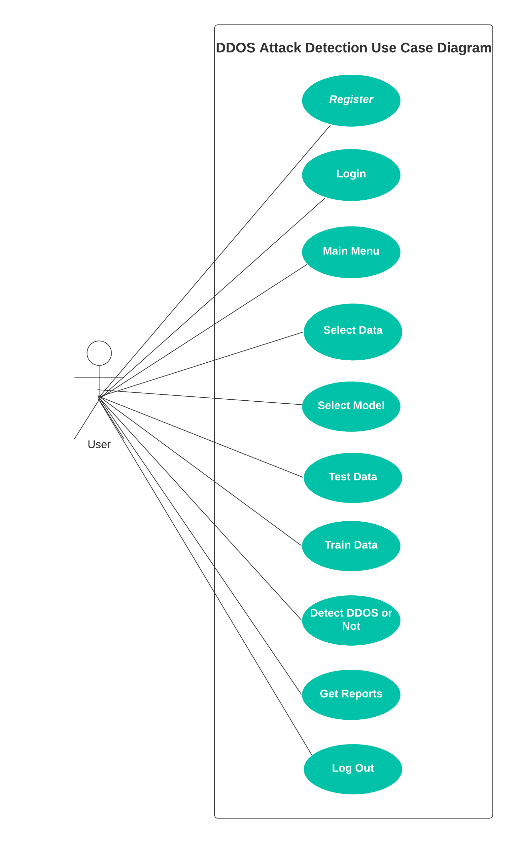

* 1. **Sequence Diagram**

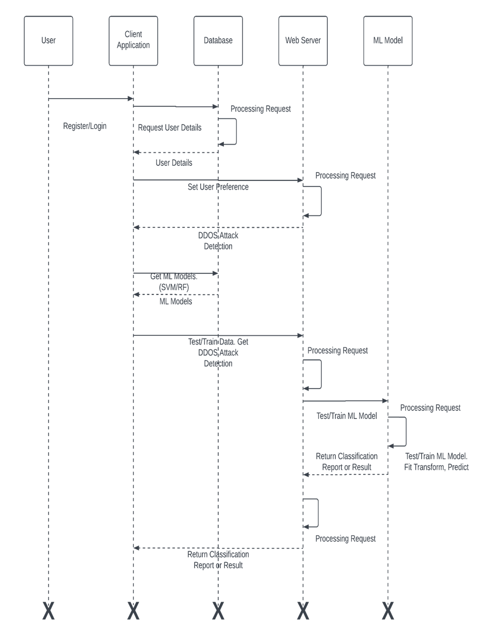

* 1. **Activity Diagram**

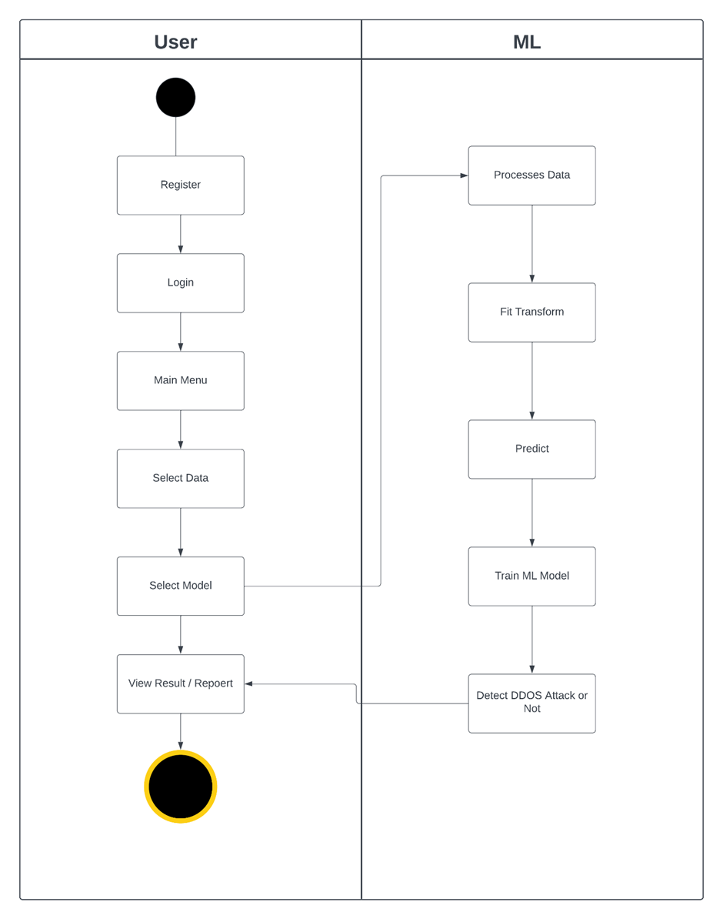

**3.5 Deployment Diagram**

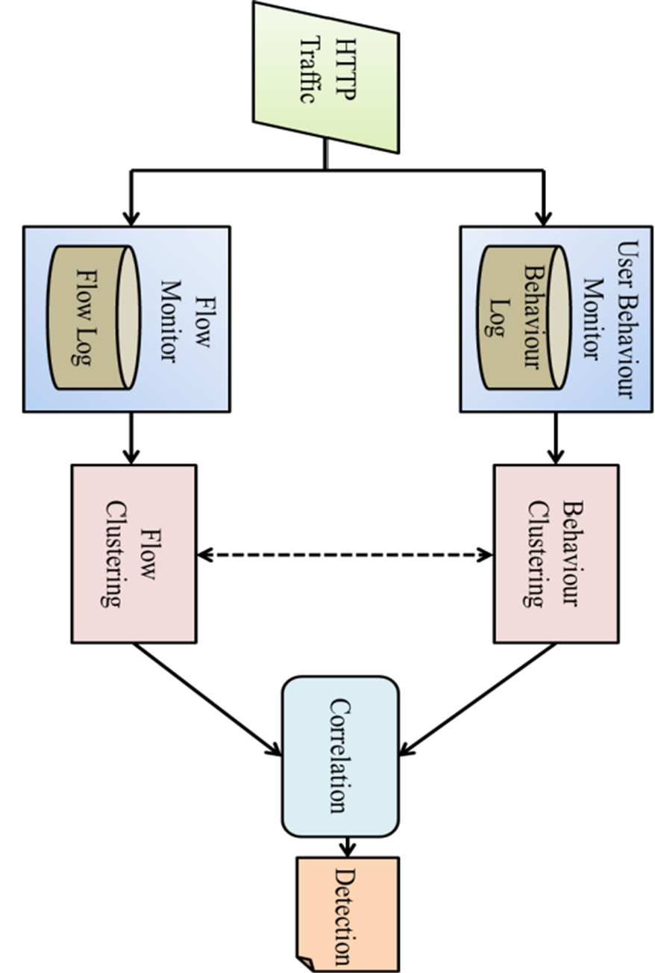

**3.6 Module Hierarchy Diagram**

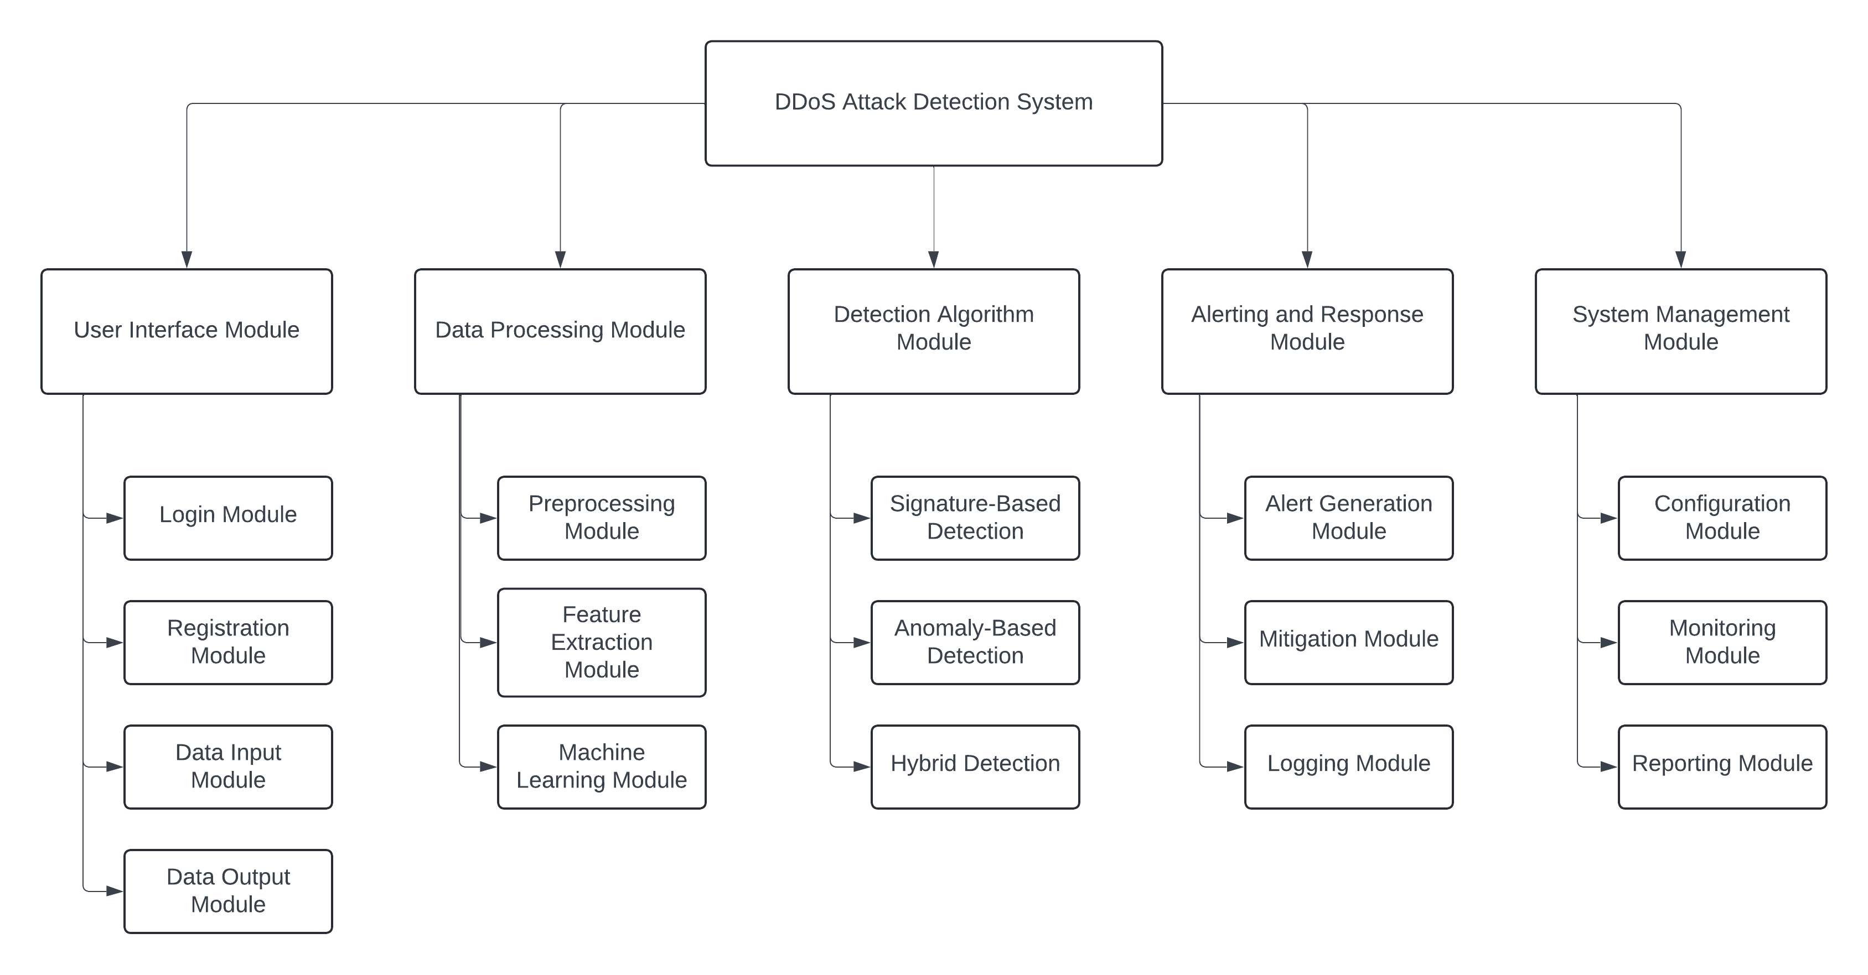

**3.7 Sample Input and Output Screens**

**Register Page :**

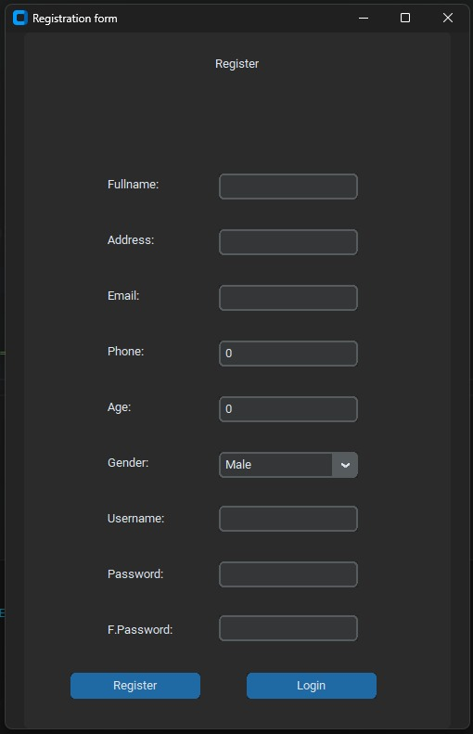

**Login Page :**

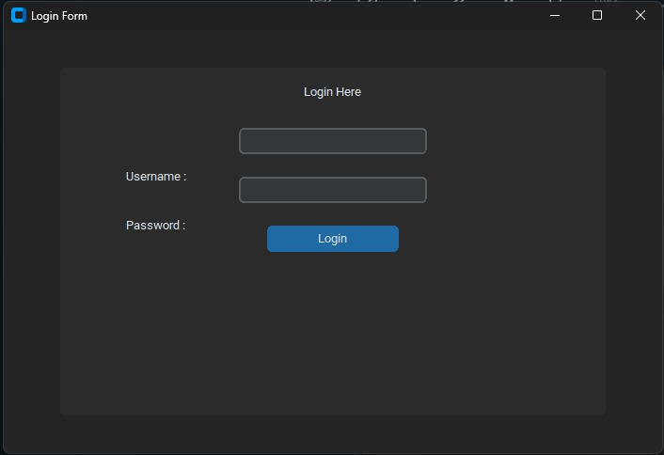

**Home Page :**

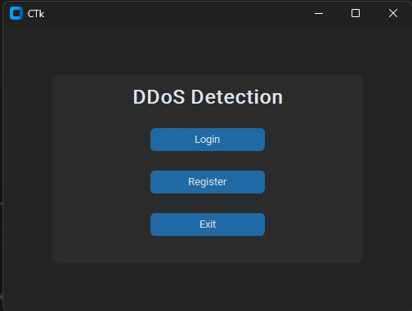

**Main Page :**

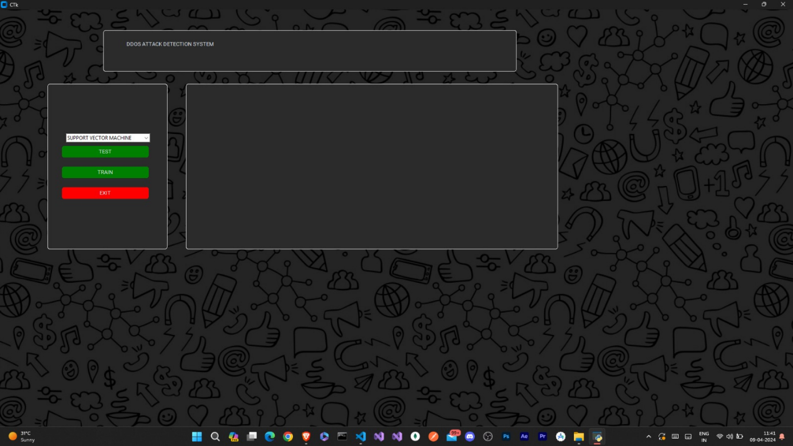

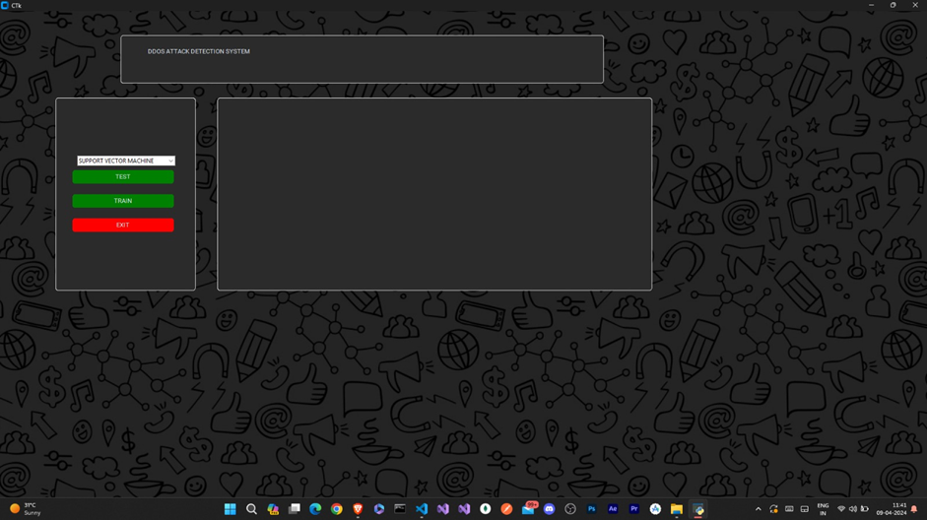

**DDOS Detection Page :**

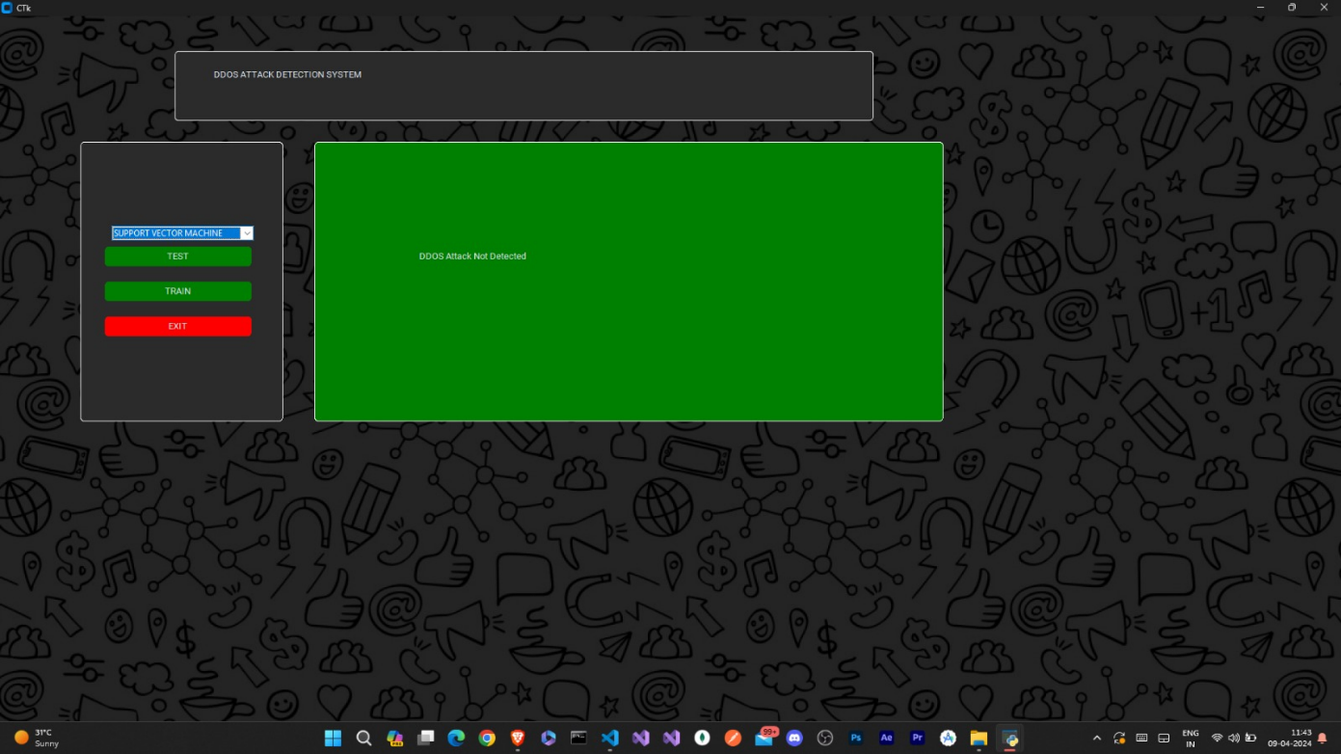

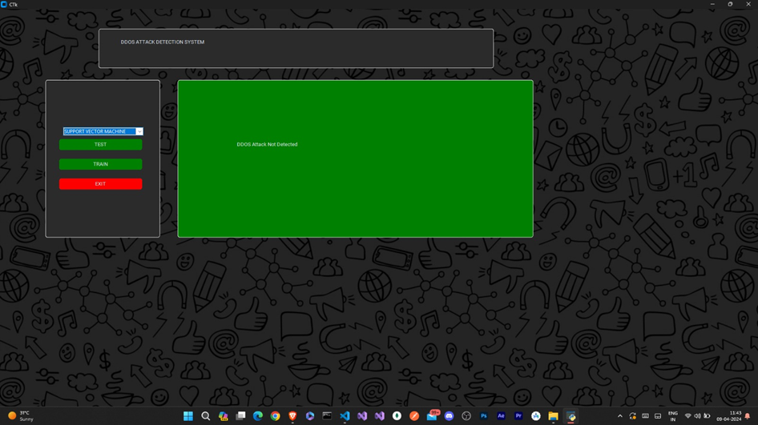

**DDOS Detection Page :**

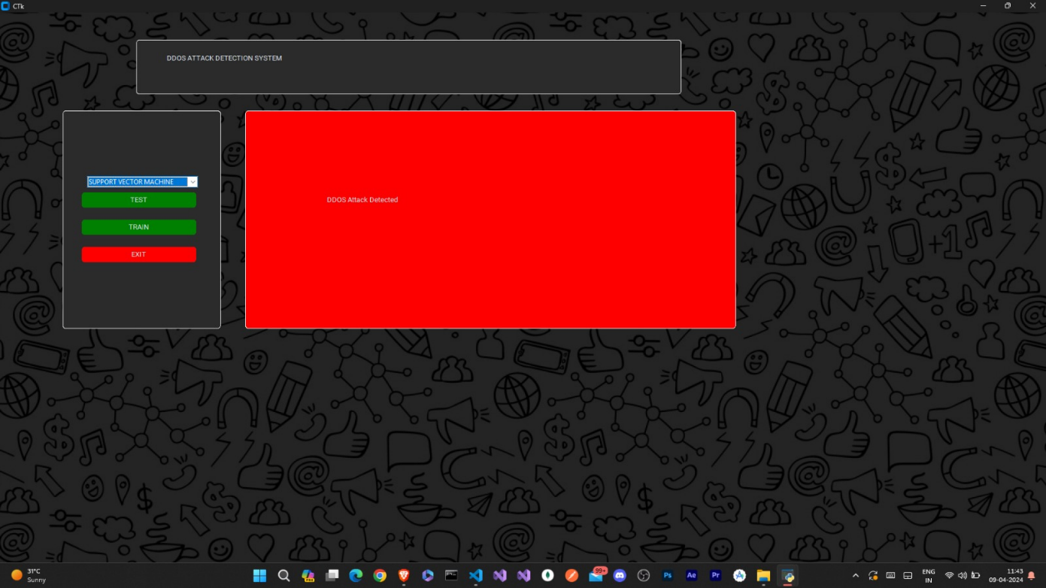

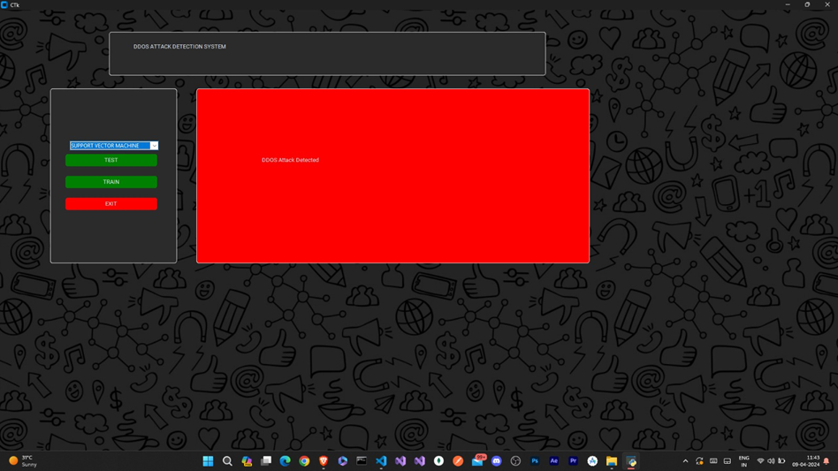

**Model Train Page :**

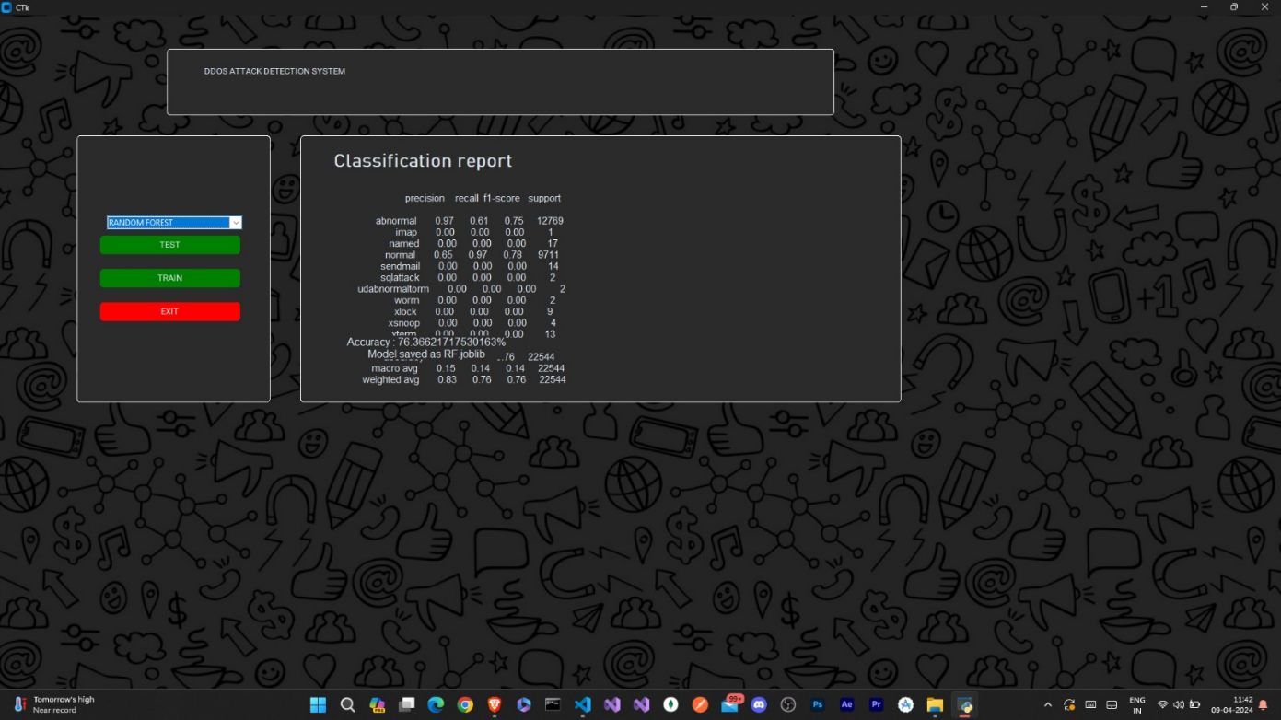

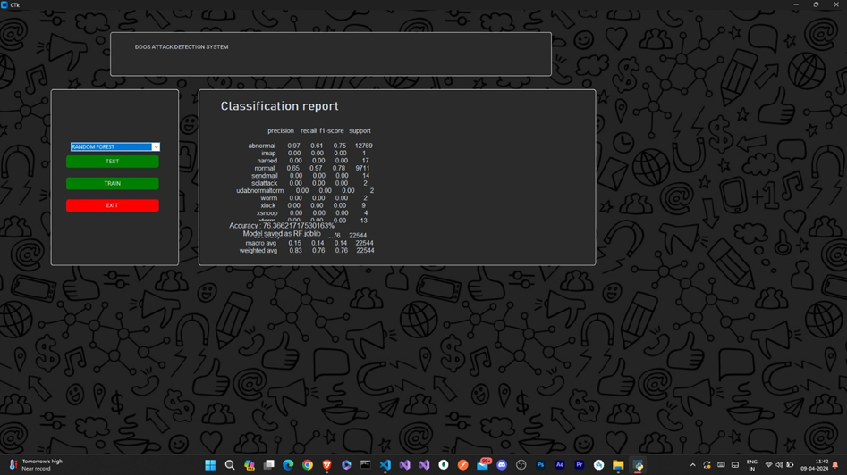

**4.** **Coding**

**4.1 Algorithms**

The DDoS attack detection system employs various algorithms and techniques to analyze network traffic, detect anomalies, and differentiate between normal and malicious behavior. Some of the key algorithms and methods used in the system include:

**Machine Learning Algorithms:**

* **Support Vector Machine (SVM):** SVM is a supervised learning algorithm used for classification tasks. In the context of DDoS attack detection, SVM can learn to classify network traffic patterns as either benign or malicious based on labeled training data.
* **Random Forest (RF):** RF is an ensemble learning method that constructs multiple decision trees during training and outputs the mode of the classes (classification) or the mean prediction (regression) of the individual trees. RF can effectively handle high-dimensional data and is robust to overfitting, making it suitable for DDoS attack detection.

**Deep Learning Algorithms:**

* **Convolutional Neural Networks (CNNs):** CNNs are deep learning models commonly used for image recognition tasks but can also be applied to sequential data such as network traffic. By leveraging convolutional layers, CNNs can extract features from network traffic data and learn complex patterns indicative of DDoS attacks.
* **Long Short-Term Memory (LSTM) Networks:** LSTM networks are a type of recurrent neural network (RNN) that are well-suited for sequential data processing. LSTM networks can capture temporal dependencies in network traffic and learn long-term patterns, making them effective for detecting subtle anomalies associated with DDoS attacks.

**Statistical Analysis Techniques:**

* **Traffic Profiling:** Analyzing historical network traffic data to establish baseline behavior and identify deviations from normal patterns. Statistical metrics such as mean, median, standard deviation, and percentile can be used to characterize normal traffic and detect anomalies.
* **Time Series Analysis:** Examining temporal patterns in network traffic data to detect sudden spikes or fluctuations indicative of DDoS attacks. Time series analysis techniques such as autoregression (AR), moving averages (MA), and exponential smoothing can be applied to identify anomalous behavior.

**Flow-Based Analysis:**

* **NetFlow Analysis:** NetFlow is a network protocol used for collecting and aggregating IP traffic data. By analyzing NetFlow records, the system can identify patterns and trends in network communication, detect volumetric anomalies, and pinpoint sources of DDoS attacks.

**Packet Inspection Techniques:**

* **Payload Analysis:** Examining the content of network packets, including headers and payloads, to identify malicious signatures, patterns, or payloads associated with DDoS attacks. Packet inspection techniques such as regular expressions, pattern matching, and signature-based detection can be used for payload analysis.

**Ensemble Learning Methods:**

* **Voting Mechanisms:** Combining the predictions of multiple base classifiers (e.g., SVM, RF) using voting mechanisms such as hard voting or soft voting to improve overall classification accuracy and robustness against diverse attack scenarios.

By leveraging these algorithms and techniques, the DDoS attack detection system can effectively analyze network traffic, detect potential threats, and mitigate DDoS attacks in real-time, thereby enhancing the security posture of the network infrastructure.

**4.2 Code snippets**

**Train Support Vector Machine :**

def SVM():

    model2 = SVC(kernel='linear',random_state=2)

    model2.fit(x_train, y_train)

    print("=" * 40)

    model2.fit(x_train, y_train)

    model2_pred = model2.predict(x_test)

    #print(model2_pred)

    print("=" * 40)

    print("==========")

    print("Classification Report : ",(classification_report(y_test, model2_pred)))

    print("Accuracy : ",accuracy_score(y_test,model2_pred)*100)

    accuracy = accuracy_score(y_test, model2_pred)

    print("Accuracy: %.2f%%" % (accuracy * 100.0))

    ACC = (accuracy_score(y_test, model2_pred) * 100)

    repo = (classification_report(y_test, model2_pred))

    label4 = ctk.CTkLabel(root,text =str(repo),width=35,height=10,bg='khaki',fg='black',font=("Tempus Sanc ITC",7))

    label4.place(x=205,y=100)

    #label5 = ctk.CTkLabel(root,text ="Accracy : "+str(ACC)+"%\nModel saved as SVM.joblib",width=35,height=3,bg='khaki',fg='black',font=("Tempus Sanc ITC",14))

    #label5.place(x=205,y=320)

    from joblib import dump

    dump (model2,"SVM.joblib")

    print("Model saved as SVM.joblib")

**Train Random Forest :**

def RF():

    #seed = 7

    frame4.tkraise();

    num_trees = 100

    max_features = 3

    model5 = RandomForestClassifier(n_estimators=num_trees, max_features=max_features)

    model5.fit(x_train, y_train)

    model5_pred = model5.predict(x_test)

    print(model5_pred)

    print("=" * 40)

    print("==========")

    print("Classification Report : ",(classification_report(y_test, model5_pred)))

    print("Accuracy : ",accuracy_score(y_test,model5_pred)*100)

    accuracy = accuracy_score(y_test, model5_pred)

    print("Accuracy: %.2f%%" % (accuracy * 100.0))

    ACC = (accuracy_score(y_test, model5_pred) * 100)

    repo = (classification_report(y_test, model5_pred))

    classrepo= ctk.CTkLabel(frame4,text ="Classification report ",width=35,font=("Bahnschrift Light",27,"bold"))

    classrepo.place(x=50,y=20)

    label4 = ctk.CTkLabel(frame4,text =str(repo),font=("Tempus Sanc ITC",15))

    label4.place(x=85,y=85)

    label5 = ctk.CTkLabel(frame4,text ="Accuracy : "+str(ACC)+"%\nModel saved as RF.joblib",width=35,height=3,font=("Tempus Sanc ITC",16))

    label5.place(x=70,y=300)

    from joblib import dump

    dump (model5,"RF.joblib")

    print("Model saved as RF.joblib")

**Test :**

def ok():

    frame2.tkraise()

    print ("value is:" + TMStateEL.get())

    model_choice = TMStateEL.get()

    choosen_model = model_list[model_choice]

    print(choosen_model)

    from joblib import load

    ans = load(choosen_model)

    from tkinter.filedialog import askopenfilename

    fileName = askopenfilename(initialdir='D:\MCA\SEM 4\PROJECT\DDoS-Attack-Detection', title='Select DataFile For INTRUSION Testing',

                                       filetypes=[("all files", "*.csv*")])

    file =pd.read_csv(fileName)

    file['protocol_type']=le.fit_transform(file['protocol_type'])

    file['service']=le.fit_transform(file['service'])

    file['flag']=le.fit_transform(file['flag'])

    qn = file.drop(["label"],axis=1)

    A = ans.predict(qn)

    print(A)

    def listToString(s):

        # initialize an empty string

        str1 = ""

        # traverse in the string

        for ele in s:

            str1 += ele

        # return string

        return str1

    print(listToString(A))

    B = listToString(A)

    if B == 'normal':

        frame2.tkraise()

        output = 'DDOS Attack Not Detected'

        frame2.configure(fg_color = 'green')

        attack = ctk.CTkLabel(frame2,text=str(output),width=30)

        attack.place(x=150,y=150)

    else:

        frame5.tkraise()

        output = 'DDOS Attack Detected'

        frame5.configure(fg_color = 'red')

        attack = ctk.CTkLabel(frame5,text=str(output),width=30)

        attack.place(x=150,y=150)

**5.** **Testing**

**5.1 Test Strategy**

The test strategy for the DDoS attack detection system involves a comprehensive approach to ensure the reliability, accuracy, and effectiveness of the system in detecting and mitigating DDoS attacks. The strategy encompasses various types of testing at different stages of the development lifecycle. Here's an outline of the test strategy:

**Unit Testing:**

* Conduct unit testing of individual components, modules, and functions of the system to verify their functionality in isolation.
* Test cases should cover boundary conditions, error handling, and expected behaviors of each unit.
* Mock external dependencies and simulate various scenarios to isolate units for testing and minimize dependencies.

**Integration Testing:**

* Perform integration testing to verify the interactions and interfaces between different modules and subsystems of the system.
* Test cases should validate data flow, communication protocols, and interoperability between components.
* Use tools like Postman or SoapUI to automate integration tests and validate system interactions across different interfaces.

**System Testing:**

* Conduct system-level testing to evaluate the overall behavior and functionality of the DDoS attack detection system as a whole.
* Test various use cases, scenarios, and user interactions to ensure that the system meets requirements and performs as expected.
* Test system performance, reliability, and usability under realistic conditions to ensure it meets user expectations.

**Performance Testing:**

* Conduct performance testing to assess the system's ability to handle high volumes of network traffic and detect DDoS attacks in real-time.
* Measure response times, throughput, and resource utilization under different load conditions to identify performance bottlenecks and optimize system performance.
* Analyze performance data to identify bottlenecks, optimize system resources, and improve overall performance.

**Security Testing:**

* Perform security testing to identify vulnerabilities, weaknesses, and potential attack vectors in the system.
* Test for common security threats such as SQL injection, cross-site scripting (XSS), and unauthorized access to sensitive data.
* Implement security best practices such as input validation, authentication, encryption, and access control to mitigate security risks.

**Stress Testing:**

* Conduct stress testing to evaluate the system's robustness and stability under extreme conditions, such as sustained high traffic loads or resource exhaustion.
* Monitor system performance, errors, and failures to identify thresholds and ensure the system can handle peak loads without disruption.
* Simulate high loads, spikes in traffic, and resource exhaustion scenarios to validate system behavior under stress.

**User Acceptance Testing (UAT):**

* Involve stakeholders, end-users, and domain experts in user acceptance testing to validate that the system meets business requirements and user expectations.
* Gather feedback, identify usability issues, and address any concerns raised by users during the testing process.
* Gather feedback from users to identify usability issues, accessibility concerns, and areas for improvement.

**Regression Testing:**

* Perform regression testing to ensure that new updates, enhancements, or bug fixes do not introduce regressions or unintended side effects into the system.
* Re-run existing test cases and verify that previously implemented features continue to function correctly.
* Automate regression tests to streamline testing efforts and ensure consistent test coverage across system versions.

**Automated Testing:**

* Implement automated testing frameworks and scripts to streamline testing efforts, improve test coverage, and facilitate continuous integration and deployment (CI/CD) pipelines.
* Automate repetitive tasks such as regression testing, performance testing, and security scanning to increase efficiency and reliability.

**Documentation and Reporting:**

* Document test cases, test plans, and test results to provide traceability and ensure comprehensive coverage of testing efforts.
* Generate test reports summarizing findings, issues identified, and recommendations for improvements to stakeholders and project teams.
* Communicate test results to stakeholders and project teams to facilitate decision-making and prioritize action items.

By following this test strategy, the DDoS attack detection system can undergo rigorous testing to validate its functionality, performance, security, and usability, ensuring that it meets the requirements and expectations of users and stakeholders.

**5.2 Unit Test Plan**

|  |  |
| --- | --- |
| **Aspect** | **Description** |
| Objective | Validate the functionality and behavior of individual units or components of the DDoS attack detection system. |
| Scope | Cover testing of each module, function, and class within the system to ensure they perform as intended and meet specified requirements. |
| Testing Approach | A combination of white-box and black-box testing techniques. |
| Testing Tools/Frameworks | Python's built-in unittest framework, pytest, or mock libraries. |
| Test Cases | Designed to cover various scenarios including normal operation, boundary conditions, error handling, and edge cases. Each test case includes a clear description, expected behavior, and steps to reproduce. |
| Test Environment | Controlled development environment using local development machines or dedicated testing servers. |
| Test Coverage | Measure test coverage metrics to ensure critical paths and functionalities are thoroughly tested. |
| Test Execution | Automatic execution as part of continuous integration (CI) process and manual execution during development and debugging phases. |
| Test Reporting | Test results logged and reported using standard reporting formats provided by testing framework. |
| Review and Validation | Review test cases and results by developers, QA engineers, and domain experts to ensure completeness, correctness, and relevance. |

**5.3 Acceptance Test Plan**

|  |  |
| --- | --- |
| **Aspect** | **Description** |
| Objective | Validate that the DDoS attack detection system meets the specified requirements and fulfills the needs of stakeholders. |
| Scope | Cover testing of the entire system in its operational environment to ensure it meets user expectations and business requirements. |
| Testing Approach | Black-box testing approach focusing on user-facing functionality and system behavior from an end-user perspective. |
| Testing Tools/Frameworks | Manual testing procedures, possibly supplemented by automated testing tools for regression testing and performance monitoring. |
| Test Cases | Designed to cover a wide range of user scenarios, including typical use cases, edge cases, and exceptional conditions. Each test case includes inputs, expected outcomes, and steps to reproduce. |
| Test Environment | Production-like environment mimicking the actual deployment environment, including network infrastructure and system configurations. |
| Test Coverage | Ensure comprehensive coverage of user requirements, functional specifications, and acceptance criteria defined in the project documentation. |
| Test Execution | Manual execution by designated testers or end-users following predefined test scripts and scenarios. |
| Test Reporting | Document test results, including observations, issues encountered, and any deviations from expected behavior. |
| Review and Validation | Review test results with stakeholders to verify that the system meets user expectations and business objectives. |

**5.4 Test Case / Test Script**

|  |  |  |  |  |
| --- | --- | --- | --- | --- |
| **Test Case ID** | **Test Case Description** | **Test Steps** | **Expected Result** | **Pass/Fail** |
| TC-001 | Verify Login Functionality | 1. Launch the application. | Login screen is displayed. | Pass |
|  |  | 2. Enter valid username and password. | User is logged in successfully. |  |
|  |  | 3. Click on the 'Login' button. | User is redirected to the home page. |  |
| TC-002 | Verify DDoS Attack Detection | 1. Generate simulated DDoS attack traffic. | DDoS attack is detected and flagged by the system. | Pass |
|  |  | 2. Monitor system logs and alerts. | Alert notification is triggered for the detected DDoS attack. |  |
| TC-003 | Verify Alert Generation | 1. Simulate abnormal network activity. | Abnormal activity threshold is reached. | Pass |
|  |  | 2. Observe system behavior and logs. | Alert is generated and logged by the system. |  |
| TC-004 | Verify System Performance | 1. Generate varying levels of network traffic. | Traffic load increases gradually. | Pass |
|  |  | 2. Measure system response time and resource utilization. | System maintains acceptable performance metrics. |  |
| TC-005 | Verify System Initialization | 1. Start the DDoS attack detection system. | System initializes without errors. | Pass |
|  |  | 2. Verify system components are loaded correctly. | System components are loaded and ready for operation. |  |
| TC-006 | Verify Configuration Settings | 1. Access system settings or configuration page. | Configuration page is displayed. | Pass |
|  |  | 2. Modify configuration settings (e.g., threshold values). | Changes are applied and saved successfully. |  |
| TC-007 | Verify Reporting Functionality | 1. Generate test data or trigger system events. | Test data/events are logged by the system. | Pass |
|  |  | 2. Access reporting or logging interface. | Logs/reports are accessible and display relevant data. |  |

**6. Limitations of Proposed System**

Here are some potential limitations of the proposed DDoS attack detection system:

* **False Positives/Negatives:** The system may generate false positives, incorrectly identifying normal traffic as a DDoS attack, or false negatives, failing to detect actual DDoS attacks. This can happen due to limitations in the detection algorithms or inadequate training data.
* **Limited Scalability:** The system's performance may degrade under high traffic loads or when monitoring a large number of network devices. Scaling the system to handle increased traffic volumes or larger networks may require additional resources and infrastructure.
* **Dependency on Training Data:** The effectiveness of the detection models relies heavily on the quality and representativeness of the training data. If the training data does not adequately capture the diversity of potential attack scenarios, the system's detection capabilities may be limited.

Addressing these limitations will be crucial for ensuring the effectiveness, reliability, and usability of the proposed DDoS attack detection system in real-world environments.

**7. Proposed Enhancements**

Here are some proposed enhancements to improve the effectiveness and capabilities of the DDoS attack detection system:

1. **Advanced Machine Learning Models:** Explore the use of more advanced machine learning algorithms, such as deep learning techniques, to improve the accuracy and robustness of DDoS attack detection. Deep learning models can automatically learn intricate patterns and features from network traffic data, potentially enhancing detection capabilities.
2. **Dynamic Threshold Adjustment:** Implement dynamic threshold adjustment mechanisms that adapt to changing network conditions and traffic patterns in real-time. This approach can help the system adjust its sensitivity levels dynamically to minimize false positives while maintaining high detection rates.
3. **Anomaly Detection Techniques:** Incorporate anomaly detection techniques alongside signature-based detection methods to identify novel and zero-day DDoS attacks. Anomaly detection algorithms can detect deviations from normal behavior and flag suspicious activities that may indicate a DDoS attack.
4. **Behavioral Analysis:** Integrate behavioral analysis capabilities to analyze the behavior of network endpoints and users for signs of anomalous or malicious activity. By monitoring and profiling the behavior of network entities, the system can identify DDoS attack patterns that may evade traditional detection methods.
5. **Real-time Traffic Analysis:** Enhance the system's ability to perform real-time analysis of network traffic by leveraging high-speed packet processing technologies and scalable data processing frameworks. This allows the system to keep pace with the increasing volume and velocity of network traffic and respond promptly to DDoS attacks.
6. **Multi-Layered Defense Mechanisms:** Implement multi-layered defense mechanisms that combine network-level, application-level, and infrastructure-level protections to mitigate the impact of DDoS attacks comprehensively. This includes deploying firewalls, intrusion detection systems (IDS), and load balancers to distribute traffic and filter out malicious requests.

By implementing these proposed enhancements, the DDoS attack detection system can become more adaptive, proactive, and effective in safeguarding network infrastructure against evolving DDoS threats.

**8. Conclusion**

In conclusion, the development of a DDoS attack detection system represents a significant step towards enhancing the security and resilience of network infrastructures against malicious threats. Through the utilization of advanced machine learning algorithms, real-time traffic analysis, and multi-layered defense mechanisms, the proposed system aims to effectively identify and mitigate DDoS attacks, thereby minimizing the impact on network availability and performance.

While the system demonstrates promising capabilities in detecting various types of DDoS attacks, it is essential to acknowledge its limitations and continuously strive for improvement. Challenges such as false positives/negatives, scalability issues, and resource constraints highlight the need for ongoing research and development efforts to enhance the system's effectiveness and adaptability in dynamic network environments.

Furthermore, proposed enhancements such as dynamic threshold adjustment, behavioral analysis, and automated response mechanisms offer avenues for strengthening the system's capabilities and resilience against emerging DDoS attack vectors. By embracing these advancements and adopting a proactive approach to cybersecurity, organizations can better safeguard their networks and mitigate the risks posed by DDoS attacks.

In essence, the proposed DDoS attack detection system serves as a crucial component of an organization's cybersecurity posture, enabling proactive threat detection, rapid response, and effective mitigation of DDoS attacks.

**9. Bibliography**

Here is a sample bibliography for the proposed DDoS attack detection system:

1. <https://ieeexplore.ieee.org/document/9187858>
2. <https://ieeexplore.ieee.org/document/9083716>
3. <https://www.kaggle.com/code/wailinnoo/intrusion-detection-system-using-kdd99-dataset>
4. <https://www.geeksforgeeks.org/machine-learning/>

These references cover various aspects of DDoS attack detection, including anomaly-based detection methods, machine learning techniques, dataset analysis, and algorithmic approaches. They provide valuable insights and research findings that can inform the design, implementation, and evaluation of the proposed DDoS attack detection system.

**10. Competition Certificates**

**Course Completion Certificate**

**Internship Completion Certificate**



**Project Completion Certificate**

**11. User Manual**

**Step 1: System Setup:**

* Install the DDoS Attack Detection System software on your computer/server.
* Ensure that the necessary hardware requirements are met, including network adapters and sufficient memory and processing power.

**Step 2: System Initialization:**

* Launch the DDoS Attack Detection System application.
* Log in using your username and password credentials.
* Upon successful login, you will be directed to the system dashboard.

**Step 3: Dashboard Overview:**

* The dashboard provides an overview of real-time network traffic statistics, including incoming/outgoing bandwidth, packet rates, and connection counts.
* Review the graphical representations and numerical data to monitor network activity.

**Step 4: Monitoring Network Traffic:**

* Navigate to the "Monitoring" or "Traffic Analysis" section of the dashboard.
* View the live feed of network traffic, including source/destination IP addresses, protocols, and packet sizes.
* Monitor for any unusual patterns or spikes in traffic that may indicate a potential DDoS attack.

**Step 5: DDoS Attack Detection:**

* The system automatically analyzes incoming network traffic using predefined algorithms and thresholds.
* In case of a suspected DDoS attack, the system generates alerts and notifications, indicating the type and severity of the attack.
* Review the alert messages and take appropriate action, such as mitigating the attack or blocking suspicious IP addresses.

**Step 6: Response and Mitigation:**

* Upon receiving a DDoS attack alert, assess the severity of the attack based on the provided information.
* Implement mitigation strategies, such as rate limiting, traffic filtering, or IP blacklisting, to minimize the impact of the attack on your network.
* Monitor the effectiveness of the mitigation measures and adjust settings as needed to ensure optimal protection.

**Step 7: Reporting and Analysis:**

* Utilize the reporting tools provided by the system to generate detailed reports on detected DDoS attacks, including attack timelines, traffic patterns, and affected network segments.
* Analyze the reports to identify trends, vulnerabilities, and areas for improvement in your network security posture.
* Use the insights gained to refine your DDoS attack prevention and response strategies for enhanced protection.

**Step 8: System Maintenance:**

* Regularly update the DDoS Attack Detection System software to ensure that it remains up-to-date with the latest threat intelligence and security patches.
* Perform routine maintenance tasks, such as database backups, system scans, and log file reviews, to ensure optimal performance and reliability.
* Stay informed about emerging DDoS attack trends and techniques to proactively adapt your defense strategies accordingly.

**Conclusion:**

By following the steps outlined in this user manual, you can effectively use the DDoS Attack Detection System to monitor, detect, and mitigate DDoS attacks, thereby safeguarding your network infrastructure against potential threats and ensuring uninterrupted service availability.

**GitHub Link :** [**https://github.com/sachinl0har/DDoS-Attack-Detection**](https://github.com/sachinl0har/DDoS-Attack-Detection)